TEMASEK POLYTECHNIC SCHOOL OF INFORMATICS & IT
DIPLOMA IN CYBERSECURITY & DIGITAL FORENSICS

AY 2022/2023 April Semester Case Study / Project
Case Study / Project Presentation

SERVERS ADMINISTRATION & SECURITY (CCD2C06) SUBJECT LEVEL: 2

GENERAL INSTRUCTIONS

- This Case Study / Project consists of 10 pages (including cover page).

- Please complete ALL tasks in this assignment.

- This Case Study / Project / Project Presentation carries 65% of the whole subject.
Content
- Assessment scores 3
- Project (65%) 3
Main tasks in this project 3
- Completion of all assigned Red Hat RH124 and RH134 Labs (30%) 4
- Individual Demonstration and Q & A (15%) 4
- Group Setup and Configuration (10%) [Self-Directed Learning] 8
- Group Presentation (10%) 9
- Deliverables 9
- Late submissions 9
- Feedback and questions 10
- Conduct 10

Assessment scores

This case study/project contributes 65% for the SADS subject. Following are the assessment components:

Assessments | Marks awarded for individual work | Marks awarded for group work
Completion of all assigned Red  Hat RH124 and RH134 Labs | 30% | -
Individual Demo and Q&A  (Section 4.1) | 15% | -
Group Research | - | 10%
Group Presentation | - | 10%
Total | 45% | 20%

Project (65%)

Main tasks in this project

- Completion of all assigned Red Hat RH124 and RH134 Labs (30%). Complete all assigned labs and submit screen captures of the output of all lab grading scripts. Refer to section 3 for details.

- Individual Demo and Q&A (15%) – please refer to section 4 for details.

In this project, you will make use of the Linux System administration and security configuration knowledge and skills acquired from the subject to:
  - Install a Linux virtual machine configured with the mandatory project requirements stated in section 4.1

- Group Setup and Configuration (10%) – please refer to section 5 for details

In the group work portion of the project, you will setup various servers and network them together. Enable prescribed services as specified in requirements in section 5. The group will submit a group report documenting the configuration steps to setup the network connectivity.

- Group Presentation (10%) – please refer to section 6 for details

As a group, you will then conduct a presentation (with slides) cum demonstration covering the following:
- Present the network design of the 4 VMs which should include the ip address scheme.
- Share with your tutor how the network connectivity is set up among the virtual machines and explain the configuration process.
- Share how the network connectivity is tested.
- Demonstrate that the required services are working correctly.

Completion of all assigned Red Hat RH124 and RH134 Labs (30%)
You would have registered for a Red Hat Login account and enrolled in both the RH124 and RH134 courseware.

In this task you will need complete the following labs and screen capture the output of the lab grading scripts at the end of each lab:

RH124
  - 3.11 Lab: Managing Files from the Command Line
  - 5.7 Lab: Creating, Viewing, and Editing Text Files
  - 6.11 Lab: Managing Local Users and Groups
  - 7.7 Lab: Controlling Access to Files
  - 8.9 Lab: Monitoring and Managing Linux Processes
  - 9.5 Lab: Controlling Services and Daemons
  - 12.11 Lab: Managing Networking
  - 13.7 Lab: Archiving and Transferring Files
  - 14.11 Lab: Installing and Updating Software Packages
  - 15.7 Lab: Accessing Linux File Systems

RH134
  - 1.7 Lab: Improving Command-line Productivity
  - 4.5 Lab: Controlling Access to Files with ACLs
  - 6.5 Lab: Managing Basic Storage
  - 7.5 Lab: Managing Logical Volumes
  - 10.7 Lab: Controlling the Boot Process

The submission of the screen captures will be via the MS Teams site assignments function. Your tutor will demonstrate to you.

Individual Demonstration and Q & A (15%)

  - The following sections from 4.1.1 to 4.1.5 list the mandatory setup, installation and configuration steps that must be completed on an individual basis.

    - Install a clean copy of a Linux operating system [setup will be demonstrated in class]

      - You may choose to setup using Cent OS Stream (version 8 or later).

      - The operating system should be setup in Oracle Virtual Box using the following parameters:
        - CPU 1 or more
        - Memory 2GB or more
        - Hard disk drive 16GB or more
        - Hard disk space should be dynamically allocated as the requirements increase (capped at the storage capacity specified in item iii)
        - Hard disk storage type is VDI.

      - The operating system should be setup to boot up in graphical user interface mode.

      - The hard disk should be partitioned during installation to the following:
Mount Point | Size | Partition Type | File System | Options
/boot | 1GiB | Linux | ext4 | defaults
/var | 2GiB | Linux | ext4 | defaults
/home | 2GiB | Linux | ext4 | defaults
swap | 1GiB | Linux Swap | swap | defaults
/tmp | 500MiB | Linux | ext4 | defaults
/ | Rest of hard  disk space | Linux | ext4 | defaults

      - Setup the root password to Passw0rd$ and an additional user account named student with password Passw0rd$.

      - Setup the timezone to local time zone (GMT+8), language to US English or UK English and keyboard to US.

After successfully setting up the Linux operating system virtual machine, you are highly recommended to create a snapshot of your virtual machine and/or export it to store as a backup in case of emergency.

    - Creating/mounting an LVM device [RH124 Chapter 15, RH134 Chapters 6 and 7]

      - Add two 1GB hard disks to the Linux VM.
      - Create the following partitions:
Device | Size | Partition Type
/dev/sdb1 | 550MiB | Linux LVM
/dev/sdb2 | Balance of disk space | Linux LVM
/dev/sdc1 | 450MiB | Linux LVM
/dev/sdc2 | Balance of disk space | Linux LVM

Volume Group
      - Using /dev/sdb1 and /dev/sdc1, create a volume group named “sadsvg”.
      - Create LVM “sadslv1” with a size of 75 logical extents (600MiB).
      - Create another LVM “sadslv2” using the available disk space on “sadsvg”.
      - Format both LVMs using ext4.
      - Mount the LVMs at /mnt/sadslv1 and /mnt/sadslv2 persistently and set the mount options to be “defaults”.
    - Create the following groups and users [RH124 Chapter 7]

User Name | UID | GID | Secondary group | Home Directory | Shell | Comments
manager | 1200 | 2000 | managers lecturers  wheel | /home/academia/manager | bash | diploma manager
teacher1 | 1201 | 2000 | lecturers wheel | /home/academia/teacher1 | bash | diploma staff 1
teacher2 | 1202 | 2000 | lecturers wheel | /home/academia/teacher2 | bash | diploma staff 2
student1 | 1001 | 1500 | NA | /home/students/student1 | bash | diploma student 1
student2 | 1002 | 1500 | NA | /home/students/student2 | bash | diploma student 2
student3 | 1003 | 1500 | NA | /home/students/student3 | bash | diploma student 3
student4 | 1004 | 1500 | NA | /home/students/student4 | bash | Diploma student 4

Group Name | GID | Primary members | Secondary members
students | 1500 | student1, student2, student3, student4 | NA
academia | 2000 | manager teacher1  teacher2 | NA
managers | 2001 | - | manager
lecturers | 2002 | - | manager teacher1 teacher2

All the user accounts password should be set to Passw0rd$.

    - Install additional software packages [RH124 Chapters 9 and 14]

      - Install the Very Secure File Transfer Protocol (vsftpd) daemon
      - Ensure that the vsftpd daemon process is automatically started every time the server reboots.

    - Create the folder structure, ownership and permission [RH124 Chapters 3, 5 and 7]

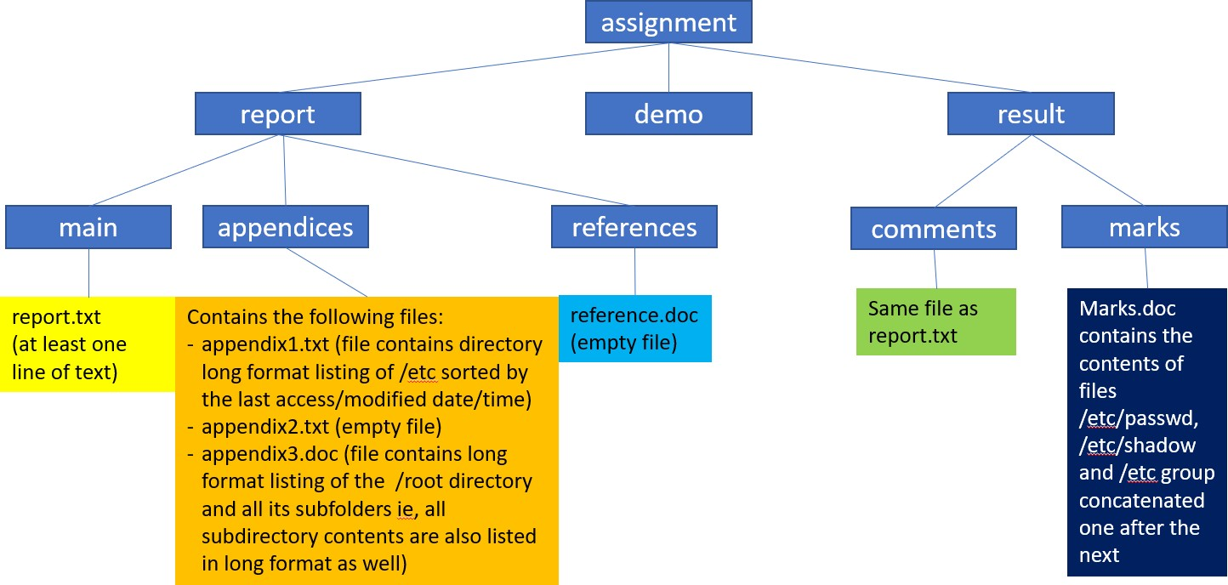

Figure 1: Folder Structure for SADS Case Study

Please note that the assignment folder and all subfolders depicted in figure 1 is to be created under the “/” folder and not in the “/root” folder.

Set the ownership and permission structure of the folder structure to the below:
Directory/file | User Owner | Group Owner | Permission
/assignment | manager | academia | 0770
/assignment/report | student1 | students | 0772
/assignment/report/* | student1 | students | 0664
/assignment/report/main | student2 | students | 0772
/assignment/report/main/* | student2 | students | 0664
/assignment/report/appendices | student3 | students | 0772
/assignment/report/appendices/* | student3 | students | 0664
/assignment/report/references/* | student4 | students | 0664
/assignment/demo | teacher1 | academia | 0751
/assignment/result | teacher2 | academia | 0750
/assignment/result/* | teacher2 | academia | 0750
/assignment/result/comments/* | teacher2 | academia | 0640
/assignment/result/marks/* | teacher2 | academia | 0640

  - Demonstration and Q&A

Each student will undergo a Q&A session of the configuration tasks above. As part of the session, you may be required to demonstrate the configuration commands, explain the output (if any) and the commands to verify. The duration of the session will be subject to confirmation.

Group Setup and Configuration (10%) [Self-Directed Learning]

Refer to the diagram above. Your group of maximum 5 members are to setup the network depicted in the diagram above.

Note that you are to propose your own IP addressing scheme. The following is suggested:
Server | # of Network Interfaces | IP Address Assignment
SSH Server | Only one (internal network) | Statically assigned
Client computer (SSH and Web) | Only one (internal network) | Statically assigned OR  Optional challenge 1: Setup a DHCP server on either the SSH or Apache Web server and obtain an IP address dynamically / automatically from the DHCP service
Apache Web Server | Only one (internal network) | Statically assigned
Optional challenge 2:

Set up a fourth Linux server that function as a network router. Once this network router is successfully setup, the SSH Server, Apache Web Server and Client computer machines should be able to access the Internet via the network router.

Base test cases
  - All three machines can successfully “ping” each other.
  - Can successfully login to the SSH server from the Client computer Terminal.
  - Can successfully access the default web page of the Apache Web Server from the Client computer browser.

Optional challenge 1:
  - The client computer is automatically assigned an IP address from the DHCP service running on either the SSH or Apache Web Server.

Optional challenge 2:
  - Show that all the other three machines can reach the Internet via the Network router linux server [note: you should demonstrate that the servers cannot reach the Internet when the network routing service is disabled or misconfigured]

You shall submit a group report documenting the steps to install, setup, configure and tests the network connectivity and network services. As a guideline, the report should contain the following sections:
- Declaration of non-plagarism
- Introduction
- Installation (include screen captures)
- Setup and/or Configuration (include screen captures)
- Testing (include screen captures)
- Conclusion
- References

You can assume that the target audience of your report is already familiar with the installation of the Linux operating system and hence do not need to include the installation steps.

Group Presentation (10%)
Each group will record a 20-25 minute video presentation (with slides and demonstration of the above test cases and any relevant OS/Vbox configuration) and upload it to Youtube. The presentation slides and URL to the Youtube video are to be submitted to TP LMS.

Deliverables
Week 15 (due 30 July 2200 hrs)
  - Complete all assigned RH124 and RH134 labs and submit all screen captures of the output of all lab grading scripts to the respective MS Teams site assignments.

Week 17 (due 13 August 2200 hrs)
  - Submit group presentation slides and Youtube video link to TP LMS.
  - Submit group report to TP LMS.

Week 17 (usual lab session)
  - Demonstration and Q&A session on individual tasks in Sections 4.1

All submission links will be made available in TP LMS within one week from the submission due date.

Late submissions
Late submissions will attract penalties:
  - Late and < 1 day – 10% deduction from absolute marks given for the part of the work
e.g. if the assignment was worth 100 marks, you were given 75 marks for the work, after the penalty you are left with 65 marks i.e. 75 – 100x10%
  - Late >= 1 and < 2 days – 20% deduction from absolute marks
  - Late >= 2 days – no marks will be awarded

Feedback and questions
You are encouraged to obtain feedback from your tutors and ask questions related to the requirements of the Project.

Conduct
Be warned that students caught plagiarising will have serious consequences.

